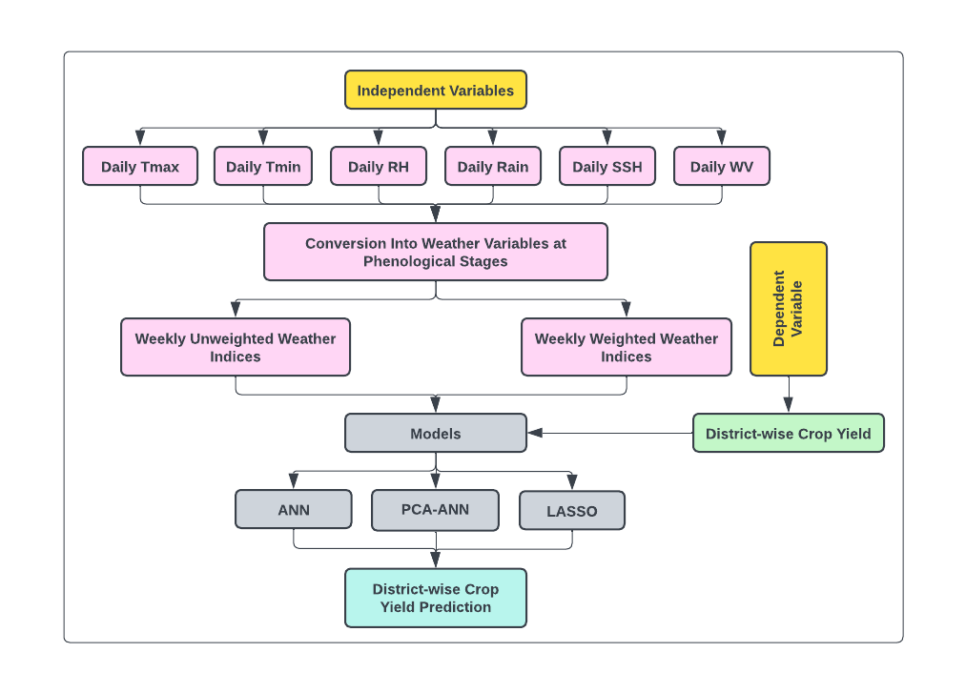

**Fig.**: Flowchart representing different stages in development of yield prediction model

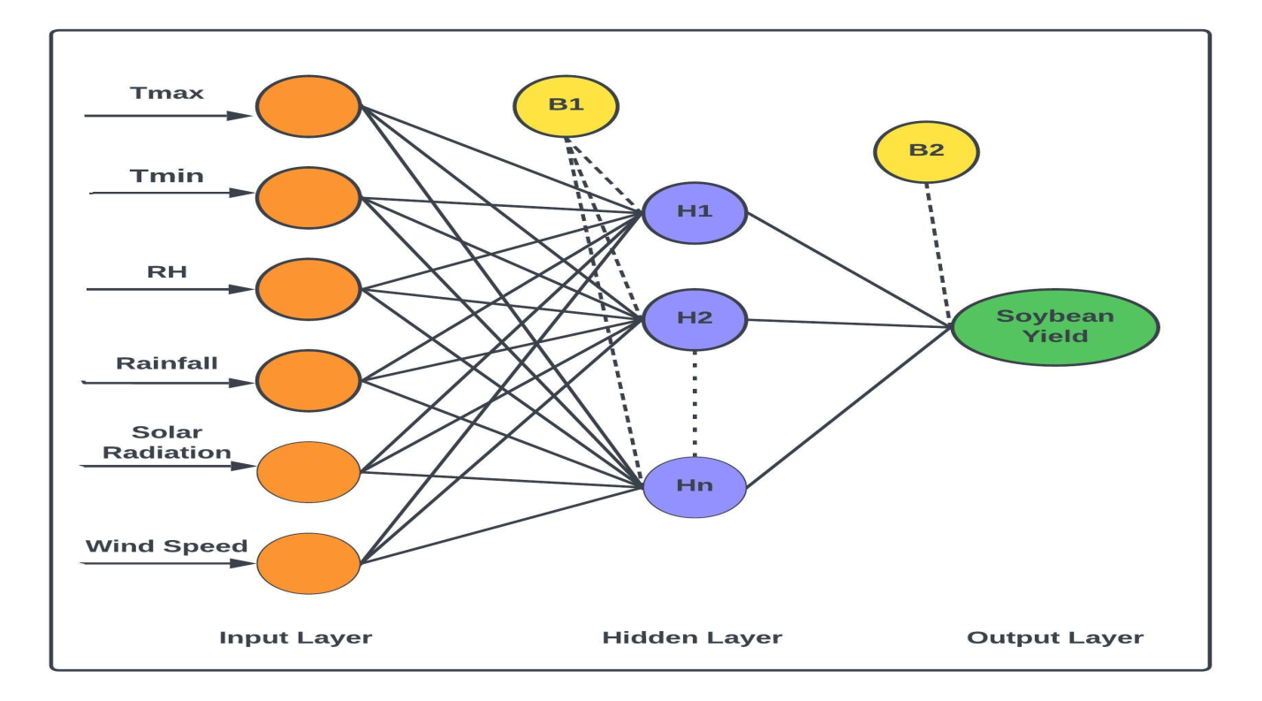

**Fig.:** Flow diagram of ANN method

**Table:** Cross comparison of the model performances based on Adjusted R2 and nRMSE values

|  |  |  |  |  |  |  |
| --- | --- | --- | --- | --- | --- | --- |
| Location | Model | Adjusted R2cal | nRMSEcal | Adjusted R2 val | nRMSEval | Overall Performance |
|  | ANN | Excellent | Excellent | Good | Excellent | Excellent |
| Udham Singh Nagar | PCA-ANN | Excellent | Excellent | Good | Excellent | Excellent |
|  | LASSO | Excellent | Excellent | Poor | Good | Good |
|  | ANN | Excellent | Excellent | Good | Excellent | Excellent |
| Almora | PCA-ANN | Good | Excellent | Poor | Excellent | Good |
|  | LASSO | Good | Good | Poor | Good | Good |
|  | ANN | Excellent | Excellent | Fair | Excellent | Good |
| Uttarakashi | PCA-ANN | Excellent | Excellent | Excellent | Excellent | Excellent |
|  | LASSO | Good | Good | Poor | Good | Fair |
|  | ANN | Excellent | Excellent | Excellent | Good | Excellent |
| Dehradun | PCA-ANN | Excellent | Excellent | Excellent | Excellent | Excellent |
|  | LASSO | Good | Good | Excellent | Poor | Fair |
|  | ANN | Excellent | Excellent | Excellent | Good | Excellent |
| Pauri-Garhwal | PCA-ANN | Excellent | Excellent | Excellent | Good | Good |
|  | LASSO | Excellent | Excellent | Poor | Poor | Good |
|  | ANN | Excellent | Excellent | Excellent | Excellent | Excellent |
| Tehri-Garhwal | PCA-ANN | Good | Excellent | Good | Good | Good |
|  | LASSO | Good | Good | Poor | Fair | Fair |
|  | ANN | Good | Good | Poor | Fair | Fair |
| Rudraprayag | PCA-ANN | Good | Good | Good | Good | Good |
|  | LASSO | Good | Fair | Poor | Poor | Fair |
|  | ANN | Excellent | Excellent | Excellent | Excellent | Excellent |
| Pithoragarh | PCA-ANN | Excellent | Excellent | Poor | Excellent | Good |
|  | LASSO | Excellent | Excellent | Poor | Good | Good |